Resource Efficient and Cleaner Production (RECP) under European Union for Environment Regional Programme

EVALUATION REPORT

on

ENERGY MANAGEMENT TRAINING

Yerevan
September 2020

From 10th to 13th of August 2020 Regional Energy management training has been organized within the EU funded EU4Environment Resource efficiency and cleaner production project by UNIDO and National Implementing Partner REC Caucasus Armenia as part of the specialized RECP trainings for RECP specialists from Armenia, Georgia and Belarus. The aim of the energy management training was to prepare internal energy auditors, RECP experts and internal energy managers ensuring practical approach to an energy audits, enriching them with knowledge on typical hot spots for energy efficiency in SMEs, and an approach how to (quickly) identify cost/benefit for energy efficient solutions. The training was conducted through Zoom platform in English. Working groups were facilitated in national languages.

The Regional Energy Management Training is aimed to support RECP experts from Armenia, Georgia and Belarus in the process of RECP assessments and identification of suitable/valid options for energy efficiency and management within SMEs. Training was focused on the following topics:
- Basics of energy management and auditing: planning of an energy audit, elements for an energy management system for SMEs, rules of the thumb, economic calculations, energy purchasing
- Engineering aspects: Energy-conscious building and renovation, heating and distribution of heat, process heat, compressed air, lighting, refrigeration, ventilation, air conditioning, electric drives, green-IT.
Training was led by Mr. Johannes Fresner, International Expert, working for EU4Environment EU funded project.

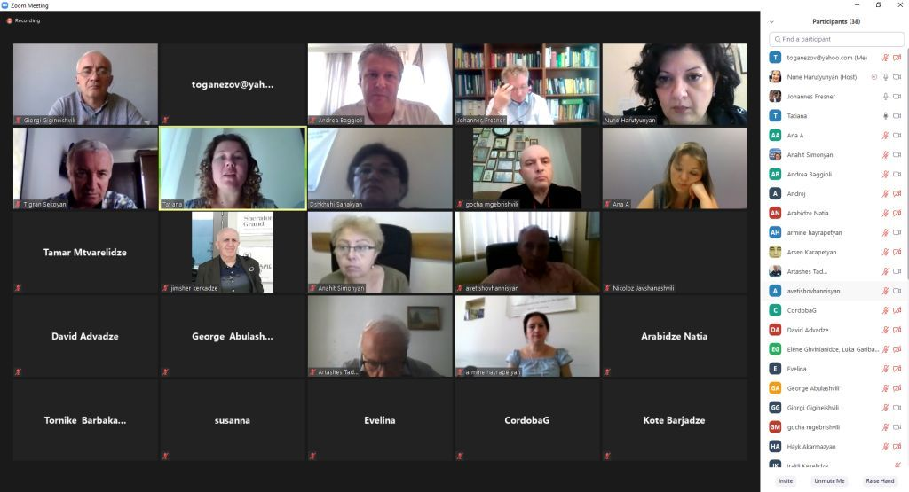
The training was attended by Mr.Andrea Baggioli, International Aid and Cooperation Officer, Delegation of the European Union to Armenia, Mr. Andrej Bartosiewicz, EU Deligation Georgia, Mr. Avetis Hovhannisyan, advisor of the Minister of Economy, EU4Environment National Focal Point, Mr. David Advadze, Technical focal point, The Ministry of Economy and Sustainable development of Georgia, Mrs. Tatiana Chernyavskaya, International Project Coordinator of EU4Environment Programme, UNIDO HQ, Mrs. Anahit Simonyan, Head of UNIDO Operations in Armenia, Mrs. Nune Harutyunyan RECP National coordinator (Armenia), Mr. Georgi Abulashvili RECP National Coordinator (Georgia), RECP National experts, academia representatives (List of participants attached in the Annex 1).

Mr.Baggioli has welcomed participants and mentioned EU’s support to EU4Environment RECP project, as well as welcomed the efforts within the project. He has mentioned that EU is satisfied by the results of the project, and will further support this effort with new initiatives supporting Circular economy and RECP promotion in the country.
Mrs. Tatiana Chernyavskaya expressed her gratitude to EU for support, welcomed the participants and presented the main goals of training. She expressed hope for the productive works during this specialized trading session.
National Focal Point from the Ministry of Economy of Armenia Mr. Avetis Hovhannisyan has welcomed participants underscoring importance of support of EU and UNIDO within the context of Circular economy promotion in Armenia, and concrete positive results implemented within the project. He has mentioned that Ministry is welcoming such initiatives, and will continue to support activities of EU4Environemnt programme, all the implementers, such as UNIDO, REC Caucasus Armenia Office, and the pool of national experts, which are an undeniable asset for further implementation of Green economy in the business sector.
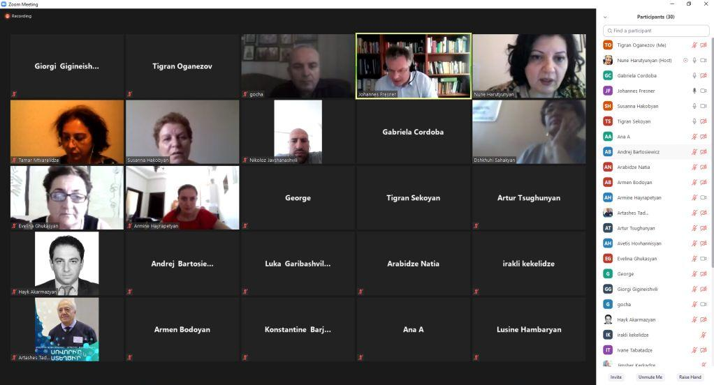
Mrs. Anahit Simonyan has warmly greeted all participants and mentioned that this online format training gave one good opportunity to organize regional events and see each other face by face. She mentioned that Energy management regional training was made possible thanks to the concrete tangible results of previous RECP project within the framework of EaP Green. EU4Environment RECP project and previous EaP Green projects aimed to show to SMEs that EU, implementing partners and government were happy to introduce of new culture, new way of the business, which is Green and Resource efficient. Within this content she has emphasized importance nexus between the Ministries of Environment and Economy. Armenia is now in the process of developing of the Country Programme and Circular Economy, Green Economy, RECP are one of main components of Armenian CP. She wished to participants’ good and productive training.
Ms. Nune Harutyunyan, National coordinator of the project, has welcomed all participants and announced the opening of the training, briefly describing the aim of the training and schedule. The training was carried out by the international expert Mr. Johannes Fresner.
The programme of this training was condensed from the content of the training program EUREM (European energy manager), a qualification for energy auditors in several European countries. This training was an introduction to the different aspects of project identification and planning for energy efficiency, especially for small and medium sized enterprises (SMEs). It includes an overview of what to look at, typical hotspots, benchmarks, rules of the thumb, and economic aspects. For each element a brief checklist was presented for direct application.
The training has gathered experienced experts from Armenia, Georgia and Belarus with a solid background in resource efficient and cleaner production and implementation of audits for SMEs from EaP countries. The experts contributed actively to practical case analysis building on their knowledge of analysing energy balances using data of mixed quality and their previous involvement with SME.

Evaluation / training summary:
International expert Mr.Johannes Fresner started the theoretical and practical part of the training by providing coherence understanding of Energy Management System. The whole presentations were accompanied with case studies, success stories and various examples which were outlining identification of challenges, losses of resources within the production cycle, possible options for reducing energy bills and costs using RECP approaches, good housekeeping, energy efficiency solutions allowing SMEs to optimize the working process and with the help of experts identify technology changes bringing long-term impact.
During training the following topics were presented to the Experts by International RECP trainer Mr.Johannes Fresner:
- Effective energy auditing for SMEs: Relevance for climate protection, characteristics of SME, appropriate audit methodology
- Heating: Heating technology, combined heat and power, distribution of heat, biomass, solar thermal, biogas, buildings, process heat and heat recovery, rules of the thumb
- Electricity consumers: Refrigeration, air conditioning and ventilation technology, compressed air, motors, pumps, fans, lighting, control strategies, rules of the thumb
- Advanced technologies and methodologies including case studies: Photovoltaics, absorption cooling, organic Rankine cycle, Pinch analysis

After each of topics participants did and discussed the following exercises:
- Exercise 1: from the overall picture to details, priorities, benchmarking.
- Exercise 2: Analysis of boilers, heat exchangers and heat distribution systems
- Exercise 3: Identification and rough evaluation of energy saving options for electric energy
- Exercise 4: Identification and evaluation of energy saving options applying advanced technologies and methods

For evaluation of results of the training project has devised an online evaluation questionnaire.
Post evaluation questionnaires was completed by the 22 training participants after the training, via the online evaluation platform (Evaluation Form, Regional Energy Management Training (10-13 August 2020), EU4Environment)

As a result of evaluation the following analysis of data obtained from participants of the training is presented. Answers of standard questionnaire are considered of 5-gradation scoring system. Charts and tables presented below solely reflect participants’ perceptions and opinions on training relevance, quality and betterment options. These tables were elaborated on the basis of responses of Energy management Training Evaluation Form created by Google Docs platform (https://docs.google.com/forms/d/1IW0mEcW68AA5Euhk9FLUJl9QJSe0umdvcGhv4uCPq7c/edit#responses).

According to assessment and analysis of result from the following issues have been revealed:

54.5% of participants were attended Energy Management training first time (Figure 1). And the training was relevant for 72.7% of respondents (Figure 2). The training content and methodology was very useful for 13 participants or 59.1% of respondent (Figure 3). The trainer was engaging and the quality of course materials were high for 72.7% of participants (Figure 4 and 5). 59.1% of respondents think that the course was practical and/or easy to apply (Figure 6). 63.6% of participants mentioned that the mix of presentations and activities suitable (Figure 7). 59.1% answered that the exercises were very helpful (Figure 8). Most of all participants mentioned that course has met their expectations and they plan to engage in further training in this area (Figure 9 and 10).

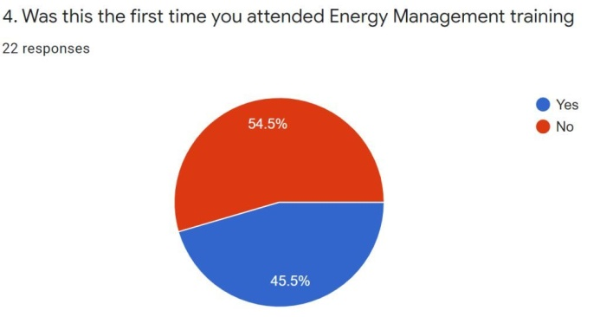 | 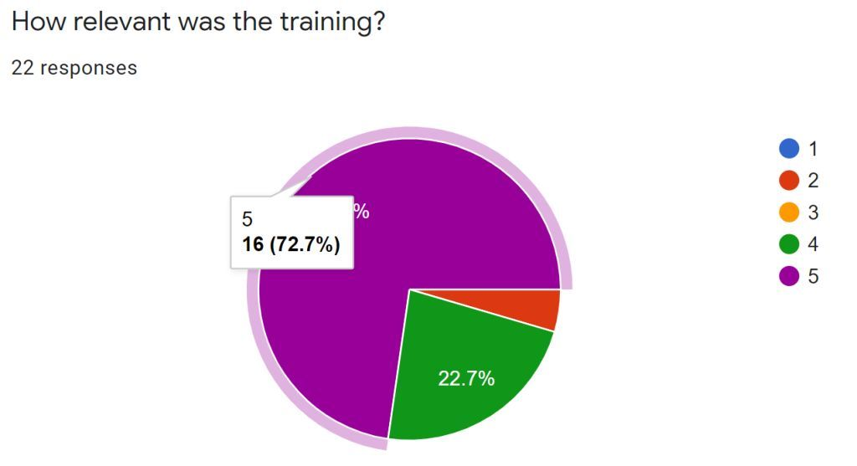
Figure 1 | Figure 2
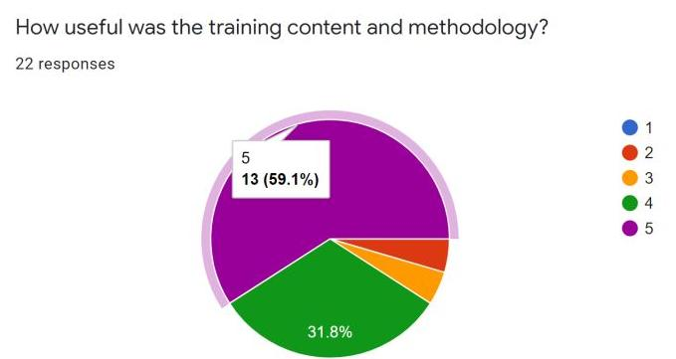 | 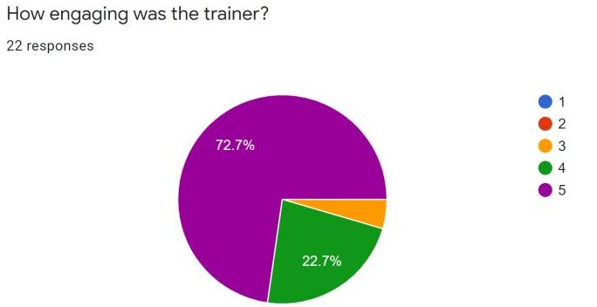
Figure 3 | Figure 4
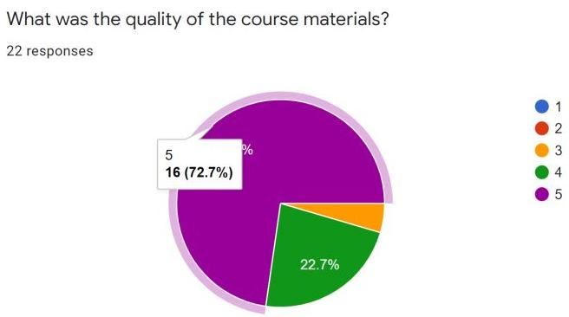 | 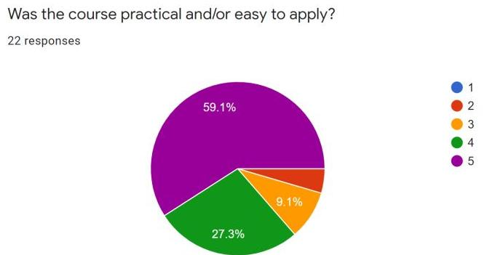
Figure 5 | Figure 6
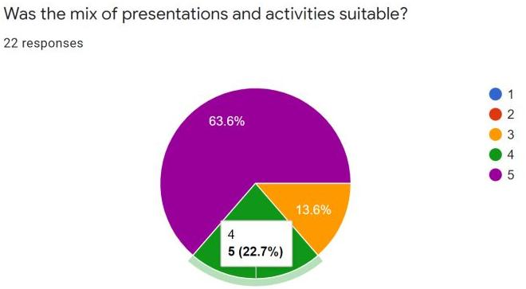 | 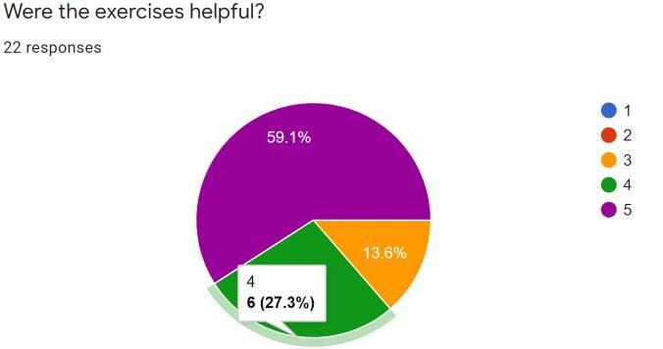
Figure 7 | Figure 8
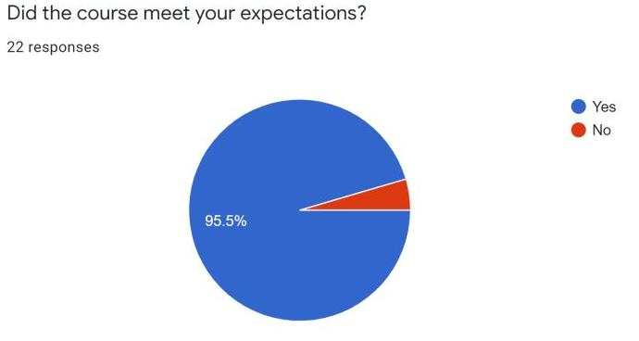 | 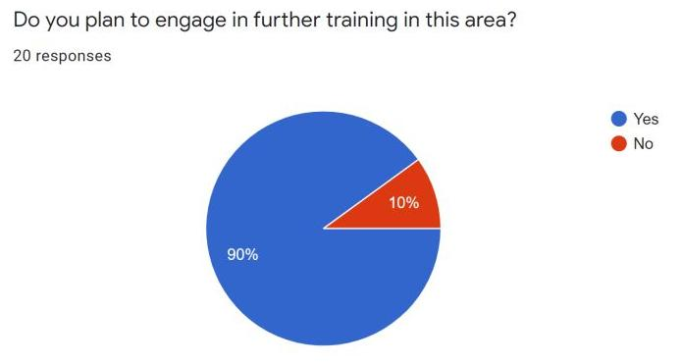
Figure 9 | Figure 10

On the question “What additional learning modules would you like to see included in the course?” participants mentioned that they would like to participate in “Health & safety in work place”, “Energy management standards, EnMS” “GHG reduction calculations”. Some of them think that the course need to include 2 additional modules regarding biogas-electric energy system and wind power usage; practical examples; the question of the use of industrial waste as secondary energy resources; deep in more details lock on formulas; the module regarding EnMS should contain more detailed and proper materials, as well as practice based business cases.

Some of the participants have mentioned that they would like to see modules on energy management system ISO 50001 and energy tariffs/subsidies included in the next training. Some participants thinks that there was a lack of time and absence of practical visits.
Some of participants suggested the following recommendations:
- more information to be provided on Energy management;
- extend the duration of the training;
- include more practical exercises in the module;
- make easier technical exercises and decrease duration of the session;
- complete the course with business cases, include info/presentations on energy policies in participating countries.
There was a suggestion to form post training groups to discuss the results of the training further, including facilitators, and the rest of the so-called ordinary and passive participants of the training.,

Participants have highly rated the handling of the online tools (Zoom and Conceptboard platforms) and the quality of organization of the training.

In general the feedback provided by participants expressed their gratitude for well organized, interesting, useful and highly appreciate the works of trainer, facilitators and organisers.

Annex 1
Resource Efficient and Cleaner Production (RECP) under European Union for Environment Regional Programme
Energy management training (10-13 of August 2020)
LIST OF PARTICIPANTS
 | Name | Position | Country | Email
 | Irina Ghaplanyan | Deputy Minister of Environment | Armenia | irina.ghaplanyan@env.am
 | Avetis Hovhannisyan | Advisor of the Minister of Economy, EU4Environment National Focal Point | Armenia | avetishovhannisyan@mineconomy.am
 | David Advadze | EU4Environment Technical focal point  The Ministry of Economy and Sustainable development of Georgia | Georgia | dadvadze@moesd.gov.ge
 | Andrea Baggioli | International Aid and Cooperation Officer, Delegation of the EU to Armenia | Armenia | andrea.baggioli@eeas.europa.eu
 | Andrej Bartosiewicz | EU Delegation Georgia | Georgia | andrej.bartosiewicz@eeas.europa.eu
 | Tatiana Chernyavskaya | International Project Coordinator of EU4Environment Programme, UNIDO HQ | Vienna, Austria | t.chernyavskaya@unido.org
 | Gabriela Cordoba | RECP Expert, UNIDO HQ | Vienna, Austria | G.CORDOBASANDOVAL@unido.org
 | Johannes Fresner | Senior Technical Advisor/Trainer | Austria | johannes.fresner@stenum.at
 | Anahit Simonyan | Head of UNIDO Operations in Armenia, | Armenia | a.simonyan@unido.org
 | Nune Harutyunyan | RECP National coordinator | Armenia | nune.harutyunyan@rec-caucasus.org
 | Armine Hayrapetyan | Project Administrator | Armenia | armine.hayrapetyan@rec-caucasus.am
 | Tigran Oganezov | Communication Expert | Armenia | toganezov@yahoo.com
 | Dshkhuhi Sahakyan | Technical Expert | Armenia | dushikner@gmail.com
 | Susanna Hakobyan | RECP Expert | Armenia | susannahakob@gmail.com
 | Vardan Tserunyan | RECP Expert | Armenia | vtserunyan@yahoo.com
 | Artur Tsughunyan | RECP Expert | Armenia | arturtsughunyan@gmail.com
 | Armen Bodoyan | RECP Expert | Armenia | armbod@yahoo.fr
 | Tigran Sekoyan | Technical Expert , Facilitator | Armenia | tigransekoyan@yahoo.com
 | Perch Bojukyan | RECP Expert | Armenia | bojukyanp@mail.ru
 | Evelina Ghukasyan | RECP Expert | Armenia | e_ghukasyan@yahoo.com
 | Artashes Tadevosyan | RECP Expert, National Polytechnic University of Armenia | Armenia | tadartashes@gmail com
 | Arsen Karapetyan | Energy Efficiency Expert | Armenia | arskarapet@yahoo.com
 | Hayk Akarmazyan | National Polytechnic University of Armenia | Armenia | akarmazian@gmail.com
 | Khachik Shahbazyan | Academia representative | Armenia
 | Lilit Gharayan | Ministry of Economy | Armenia
 | Mariam Ghazaryan | Ministry of Environment | Armenia
 | Nune Sakanyan | Ministry of Environment | Armenia
 | Georgi Abulashvili | RECP National Coordinator | Georgia | g_abul@eecgeo.org
 | Konstantine Barjadze | Technical Expert Project Team, Facilitator | Georgia | k_barj@eecgeo.org
 | Nodar Kevkhishvili | Technical Expert Project Team, Facilitator | Georgia | nodar_ke@yahoo.com
 | Irakli Kekelidze | Environmentalist GAMA Consulting | Georgia | Irakli.kekelidze81@gmail.com I.kekelidze@gamma.ge
 | Jimsher Kerkadze | Environmentalist GTU Department of Chemistry | Georgia | j.kerkadze@gtu.ge
 | Ivane Tabatadze | Electrical Engineer State El. Company GSE | Georgia | vano.tabatadze14@gmail.com
 | Elene Ghvinianidze | Geographi ecology - Project Assistant | Georgia | e_ghvi@eecgeo.org
 | Nikoloz Javshanashvili | RECP Club Expert - Project Team | Georgia | nickajavshanashvili@yahoo.com
 | Giorgi Gigineishvili | GTU Department of Thermal Energy and Energy Efficiency | Georgia | gogigin@Yahoo.com;  g.gigineishvili@gtu.ge
 | Luka Garibashvili | Ministry of Economy and Sustainable Development of Georgia, Energy Policy Department, Intern GTU B.A Power and Electrical Engineering | Georgia | garibashvili.luka@gtu.ge; Luka_garibashvili@yahoo.com
 | Tornike Barbakadze | GTU Envir. Engineering and Safety | Georgia | tornikebarbakadze161@gmail.com
 | Ana Antelava | PhD Student , Process and Energy Engineering London South Bank University —Nov 2017 - Nov 2020 | Georgia | annantela@gmail.com
 | Gocha Mgebrishvili | LLC “Geosteel” (Steel Plant)  Position: Health, Safety and Environment Manager | Georgia | gmgebrishvili71@gmail.com
 | Tamar Mtvarelidze | CENN,Monitoring and Compliance Specialist | Georgia | mtvarelidze@yahoo.com
 | Natia Arabidze | GTU Department of Thermal Energy and Energy Efficiency | Georgia | arabidze.natia@yahoo.com
 | Marta Sassella

