REPORT
Workshop “ENVIRONMENTAL MANAGEMENT SYSTEM” by Johannes Fresner within EU4Environment Programme framework
July 30-31, 2020

CONTENT
Report

Agenda …………………………………………………………………………………………3
Participants …………………………………………………………………………….…….3
Technical part………………………………………………………………………………..3
Meeting overview …………………………………………………………………………4
Outcomes ……………………………………………………………………………………..9
Evaluation of the training…………………………………………………………... 10
Post-releases, video …………………………………………………………………….11

Annex 1 – Agenda
Annex 2 – List of participants
Annex 3 – List of participants (divided into groups)
Annex 4 – Technical note (before the workshop)
Annex 5 – Technical details (during the workshop)
Annex 6 – Presentation used during the event
Annex 7 – List of practical exercises
Annex 8 – Practical exercises results
Annex 9 – Evaluation form
Annex 10 – Evaluation form analysis

Alex Leshchynskyy briefly presented the UNEPs component under the EU4Environment Programme and introduced the issue of Eco-innovations to improve sustainability of the product life cycles and building resilience in the post COVID-19 era (see Figures 4, 5, 6).

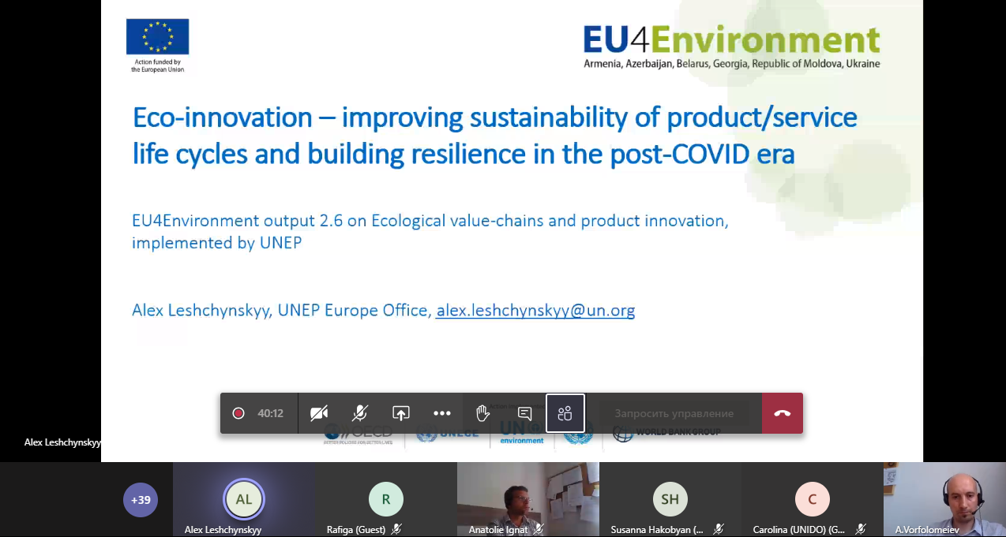

Figure 4 – Presentation of Eco-innovations to improve sustainability of the product life cycles and building resilience in the post COVID-19 era

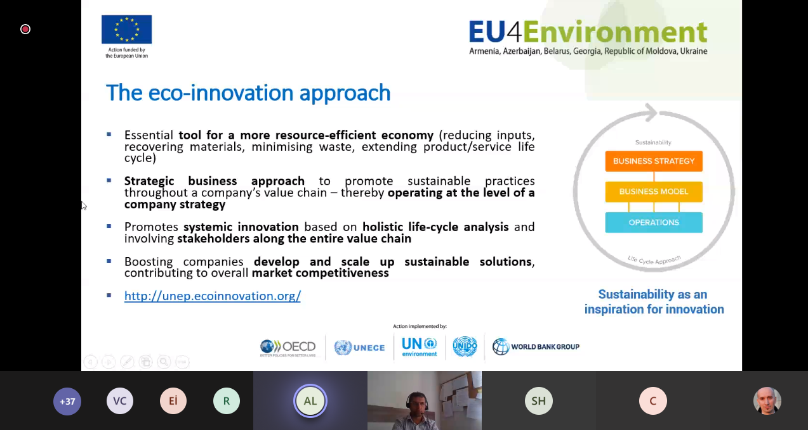

Figure 5 – Presentation of Eco-innovations to improve sustainability of the product life cycles and building resilience in the post COVID-19 era
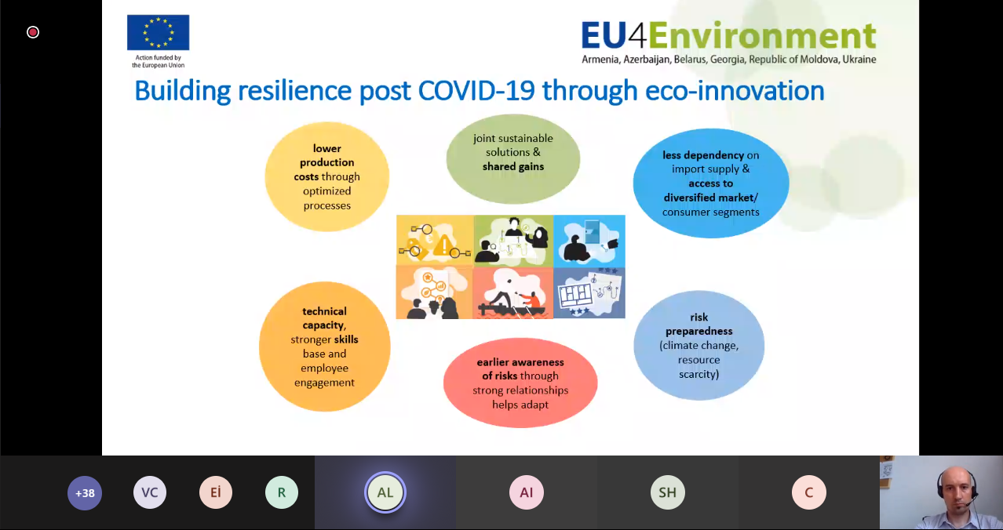

Figure 6 – Presentation of Eco-innovations to improve sustainability of the product life cycles and building resilience in the post COVID-19 era

Then the floor was given to Dr. Johannes Fresner, an Austrian engineer supporting the EU4Environment Programme. He has been working in RE, CE, EMS, and EM since 1992. He has worked for various industries like food processing, metal processing, plastic processing, wood processing, steel, paper, chemicals.
Johannes Fresner presented some rules, agenda and tasks of both the theoretical and practical parts of the workshop and actually started the main part of the event (Annex 6 and Figures 7, 8).

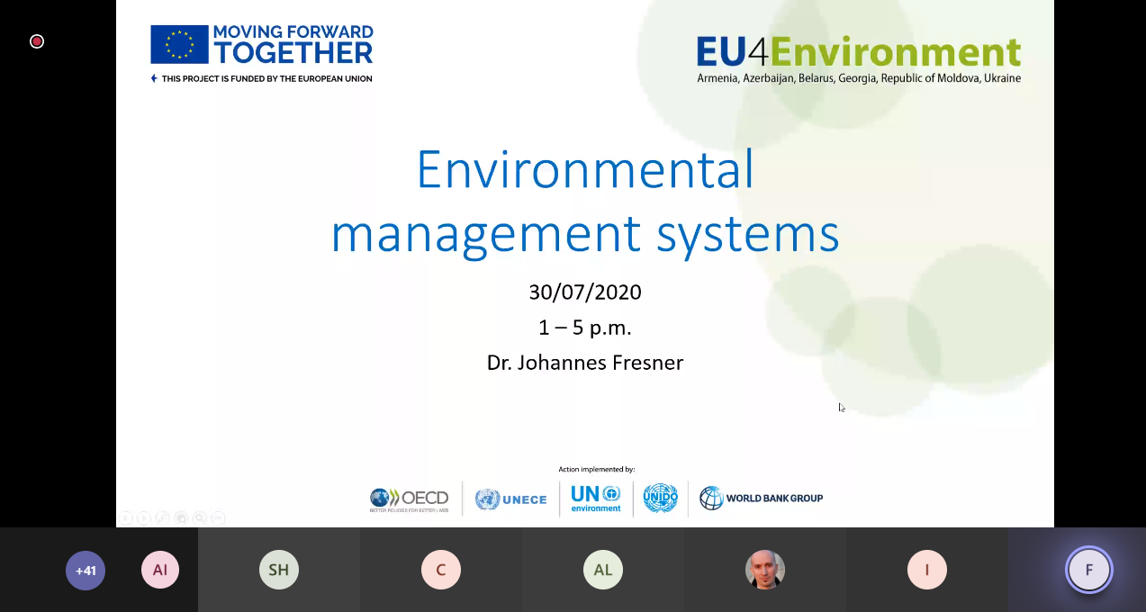

Figure 6 – Theoretical part, day 1

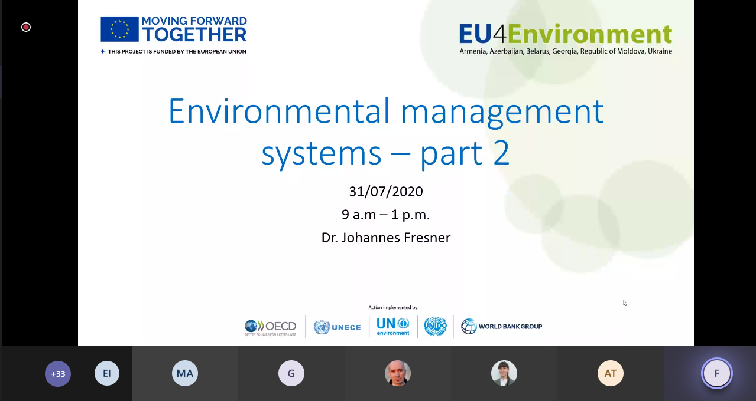

Figure 7 – Theoretical part, day 2

Practical tasks
Each theoretical topic presupposed performing practical assignments. According to the agenda, each of the 6 groups had to solve 2 practical exercises each day (Annex 7, 8).
The facilitators had to organize the work in groups and then present the results of the exercise in the main group (Figure 8).

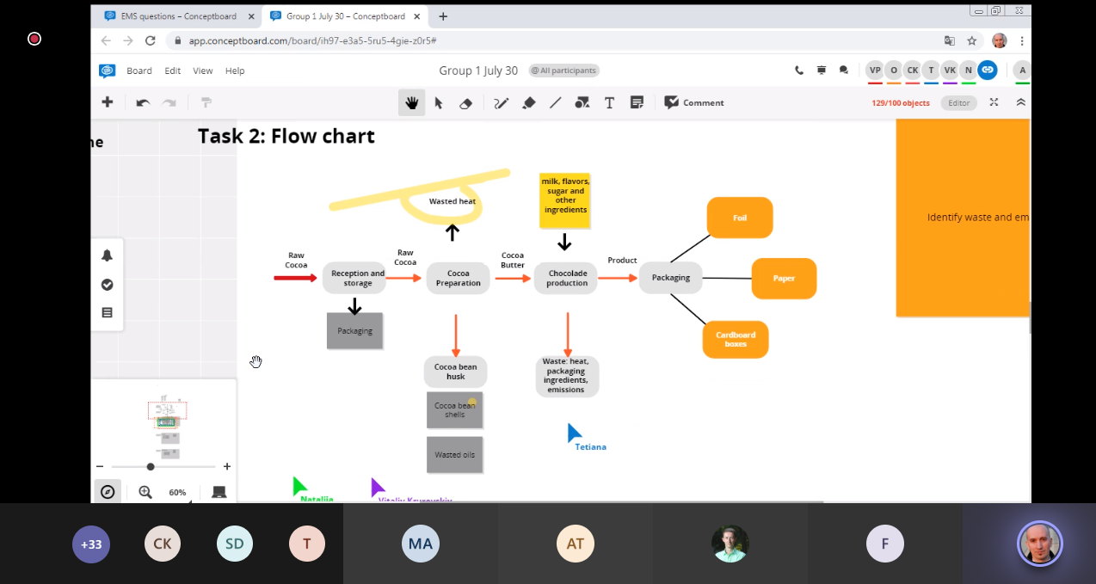

Figure 8 – Practical part (Group 1)

